Mason, 7th NOV 2016

Cheap Laser Rangefinder using Arduino.
(proof of concept)

From Wikipedia:
A rangefinder is a device that measures distance from the observer to a target, in a process called ranging.

Experiment:
A laser is pointed to the object whose distance we want to measure.
A linear array of photodiodes is used to detect the position of the reflected laser light.
Calculations similar to center of mass are used to find the position of the brighter spot in the array (single line image).
The position of the brighter spot in the array will be used to obtain the distance to the object trough trigonometric calculations.

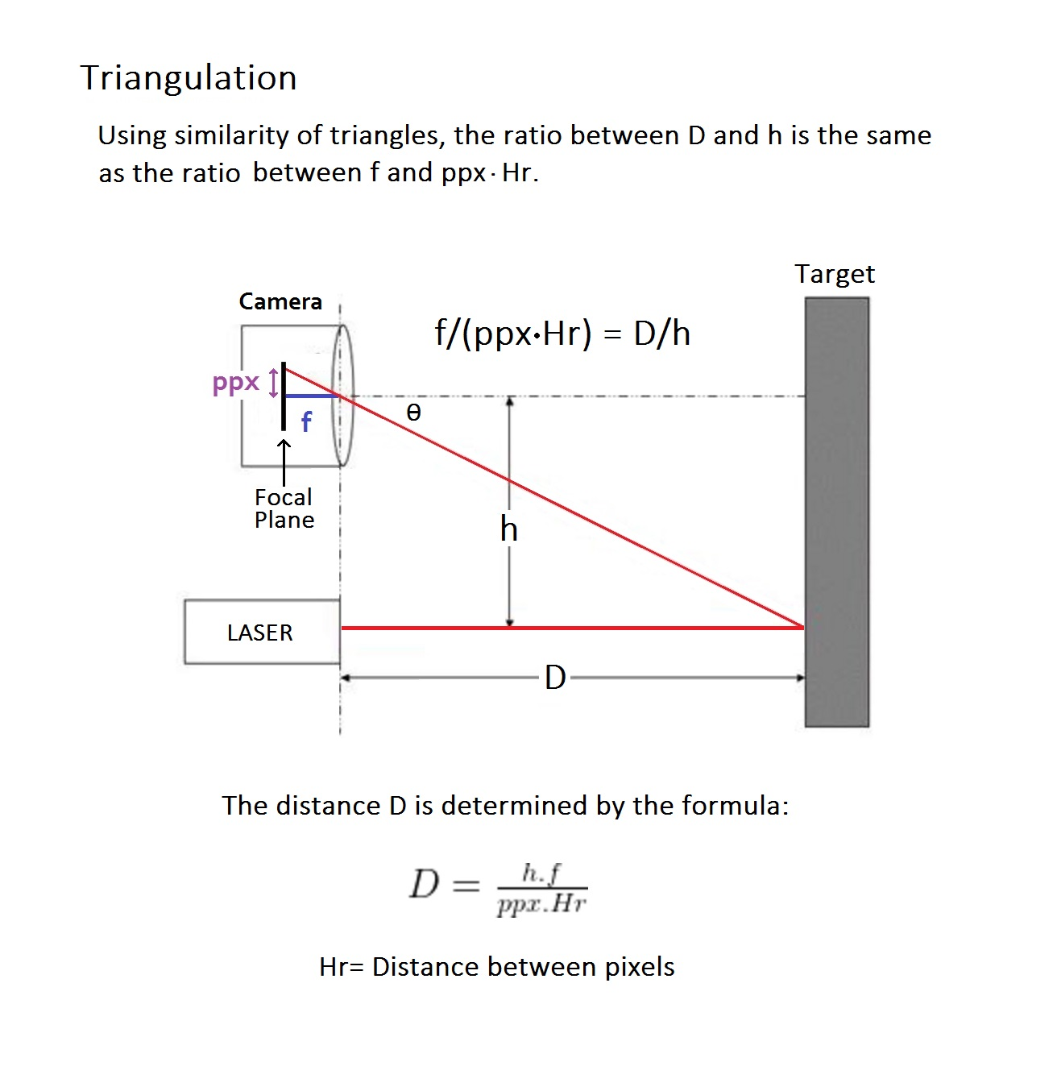
Image of the linera array:

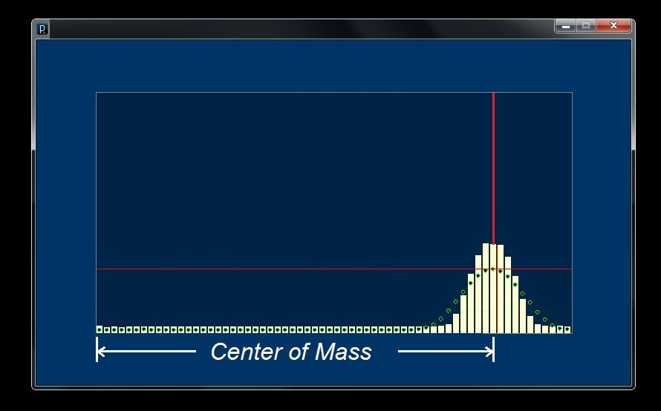

Center of Mass calculation:
